Assessment 1

Creativity and Innovation in Every Day Life
z5763342

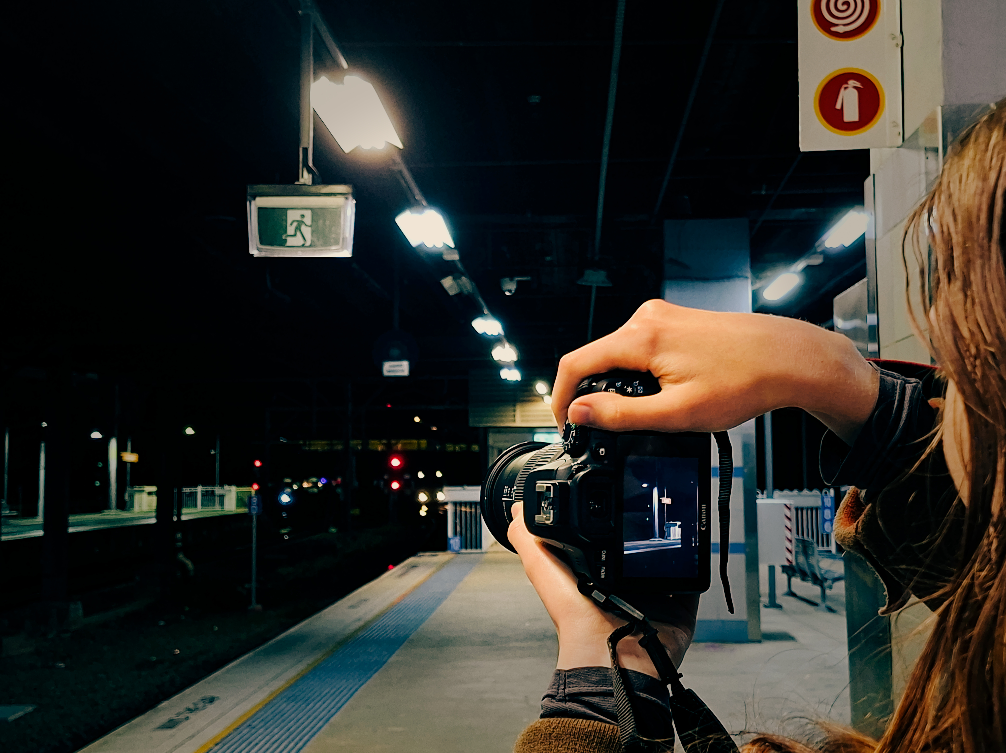
Figure 1: Creativity in the every day

Figure 1 depicts a photographer taking photos on the platforms of Hurstville station during the night. This creative moment stood out to me in particular since no significant event was occurring at the time. I reflected on how art forms are one of the most sincere means of creating and sharing ideas due to absence of risk or pressure.
Photographers have one of the most forgiving mediums, encouraging growth in creative confidence and allowing them to explore their own beliefs and feelings. Without feeling the pressure to perfect any singular frame, a photographer can take thousands of photos without judgement, facilitating the development of divergent thinking skills. The freedom that exists in sheer volume is the foundation in understanding that finding meaning or an end goal does not have to be forced, but can emerge through repetition and the embrace of curiosity. In photos that have no particular interest point such as that taken in Figure 1, value comes not from capturing something breathtaking, instead by expressing some original feeling.
This photo also demonstrates the fundamental process of building creative confidence. Initially, the photographer tests out a multitude of different ideas and methods such as framing and exposure in a zero-stakes environment rather than waiting for the perfect moment. Then by reflecting on differing results, the photographer adapts their technique to create a frame that they believe better captures the idea that they wish to present. Finally, and most crucially, the value of each photo is realised by the photographer as something that they have developed and created.
Photography is a personal interest of mine, and seeking originality rather than interest has developed my divergent thinking ability as well as creative confidence that has brought noticeable improvement to my work. Figure 1 has illuminated how creativity permeates through my own day-to-day life, a reminder that creative thinking does not necessitate an intentional environment, but the ability to notice the seemingly mundane.

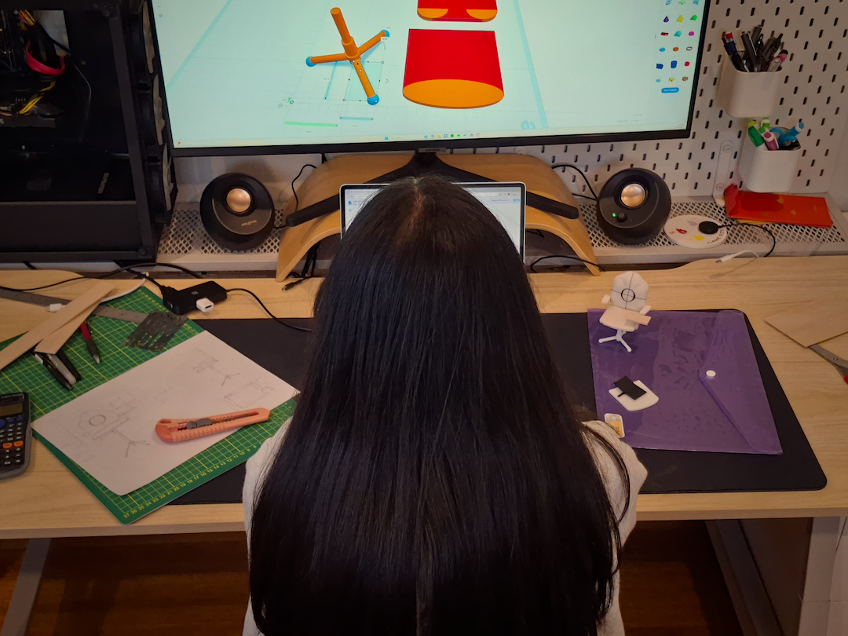
Figure 2: Innovation at home

Figure 2 was taken at home, showing a sibling working on a long term project. I took this photo since it encapsulates the defining features of the innovative process in a single image, but also reveals how much of the process remains invisible. An outsider observer can only appreciate an innovation through its outcome, yet it is the entire process, from the critical early weeks of development to the middle stages of iteration that ultimately shape the final product.
The photo visually represents convergent thinking, where a single idea is continuously evaluated and reshaped to reach a end goal. This reflects the process of developing an idea into an innovation, from capturing an idea, prototyping and iterating it, and finally reflecting on the final product. Figure 2 demonstrates many different stages of iteration, from the initial drawings on the left side, to the prototype model on the right, and finally a developing 3D model on the computer screen. A similar process defines all innovations as products of an initial idea, as well as the planning and development into a final idea.
A single image cannot capture the entire journey and I am only able to depict a specific moment in a much larger process. The ability to acknowledge and adapt to shortcomings is one of the most crucial and demanding part of innovating, particularly in environments that treat mistakes as only mistakes, rather than opportunities to learn from.
I was particularly impressed with the newfound accessibility to innovation that modern technology has created. The tools visible in Figure 2 such as hand sketching and technical drawing have existed for hundreds of years, but later stages of prototyping into physical models no longer require manual skills, where computer aided modelling and 3D printing can replace expensive and complex equipment. Figure 2 serves as a reminder that innovation is accessible to anyone, given a powerful idea and the perseverance and ability to adapt to the ever changing world.

Overall, I have discovered how creativity and innovation exist in my own every day life. Despite these concepts shaping the world around us, seeing them requires looking for it intentionally. Taking these photos has made me more aware and appreciative of innovative processes, and I have found myself more confident in my own ability to develop upon my own original ideas.

Appendix
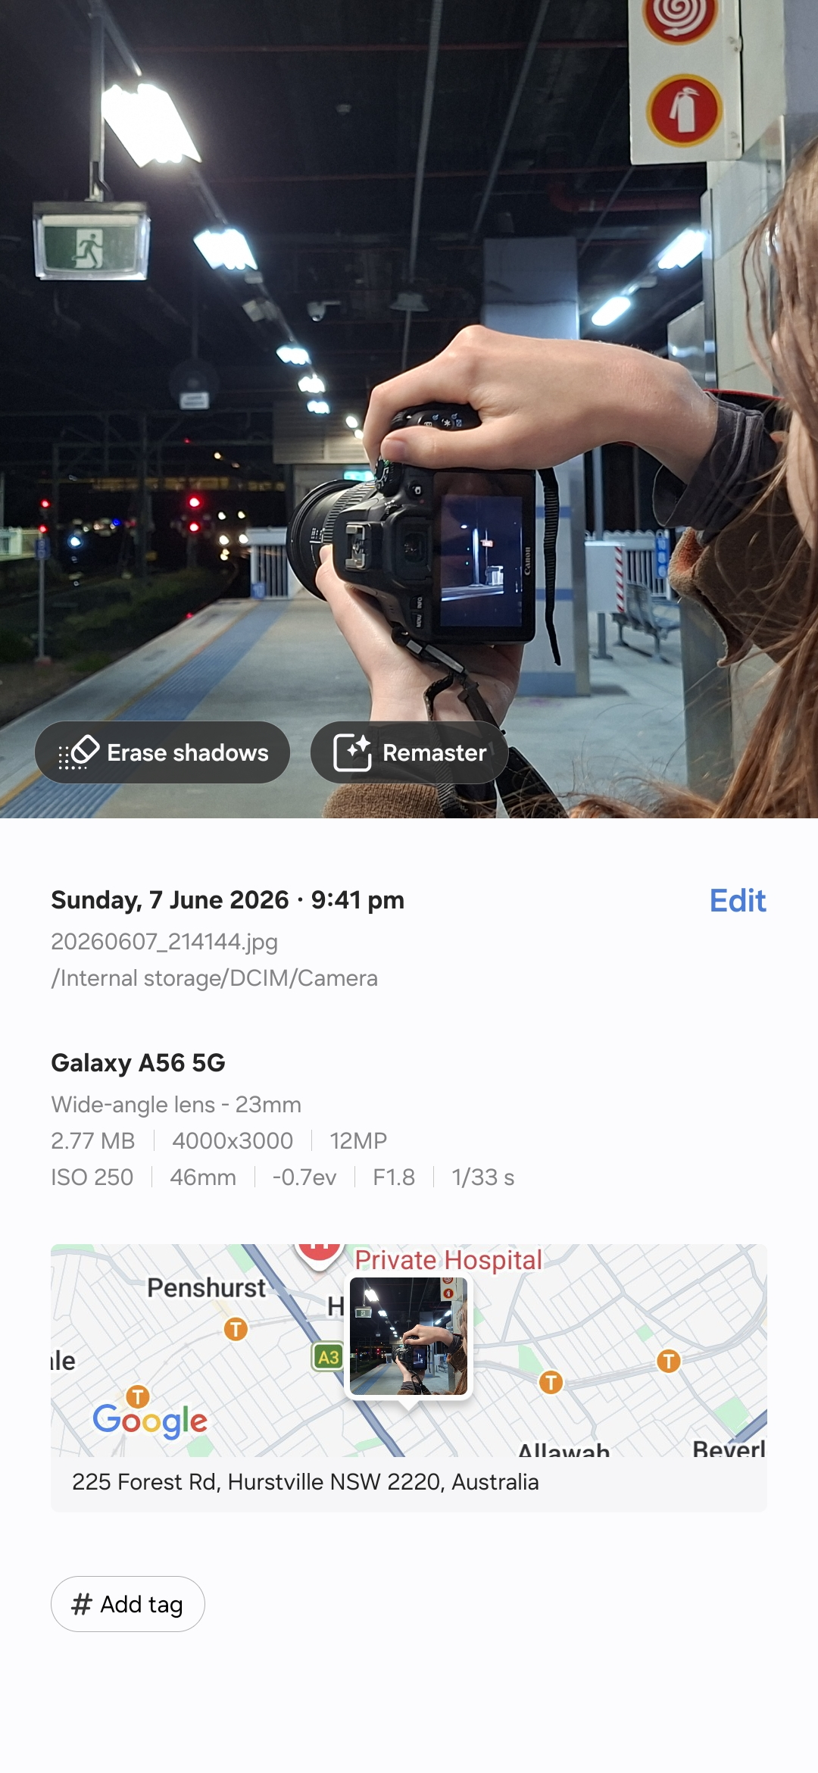
Figure 1 metadata
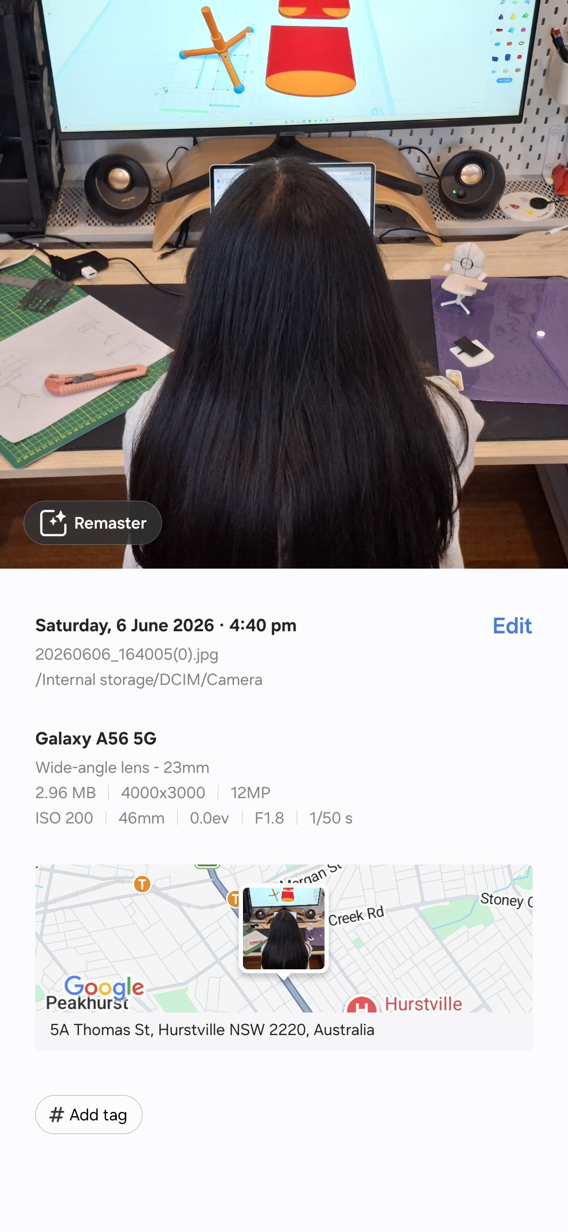
Figure 2 metadata

